EXP. NO: 17
PERFORMANCE EVALUATION OF DIGITAL COMMUNICATION SYSTEMS USING EYE DIAGRAM
ANALYSIS UNDER ADDITIVE WHITE GAUSSIAN NOISE (AWGN) USING MATLAB

MATHLAB CODE:
clc;
clear;
close all;
%% Parameters
N = 100; % Number of bits

sps = 20; % Samples per symbol
SNR = 10; % Signal-to-Noise Ratio (dB)
%% Generate Random Binary Data
data = randi([0 1],1,N);
%% NRZ Encoding (0 -> 0, 1 -> 1)
tx_signal = repelem(data,sps);
%% Pass Signal through AWGN Channel
rx_signal = awgn(tx_signal,SNR,'measured');
%% Time Axis
t = (0:length(tx_signal)-1)/sps;
%% Plot Results
figure;
% Original Binary Data
subplot(4,1,1)
stairs(data,'LineWidth',1.5)
grid on
title('Original Binary Data')
xlabel('Bit Number')
ylabel('Bit')
ylim([-0.2 1.2])
% Transmitted NRZ Signal
subplot(4,1,2)
plot(t,tx_signal,'LineWidth',1.5)
grid on
title('Transmitted NRZ Signal')
xlabel('Time')
ylabel('Amplitude')
ylim([-0.5 1.5])
% Received Signal after AWGN
subplot(4,1,3)
plot(t,rx_signal,'r')
grid on
title(['Received Signal with AWGN (SNR = ',num2str(SNR),' dB)'])
xlabel('Time')
ylabel('Amplitude')
% Eye Diagram
subplot(4,1,4)
eyediagram(rx_signal,2*sps)
title('Eye Diagram of Received Signal')

WAVEFORM:

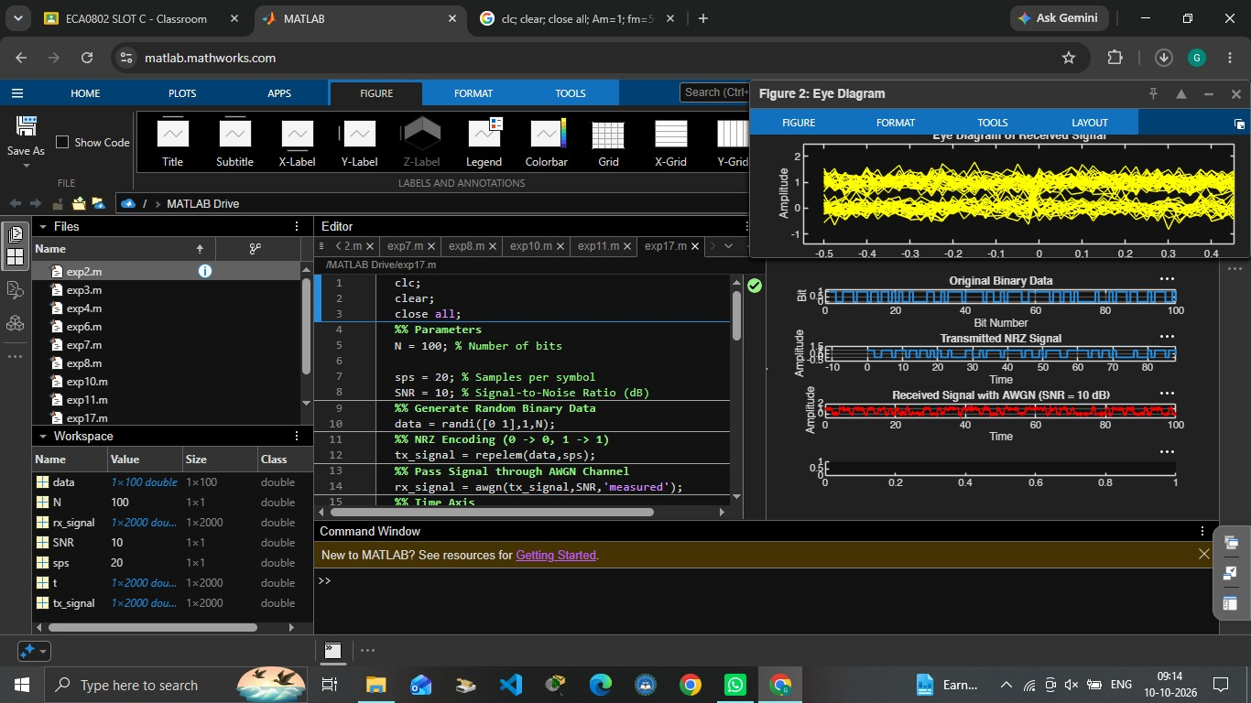

OUTPUT:

